Friday, October 24, 2025
Guidelines

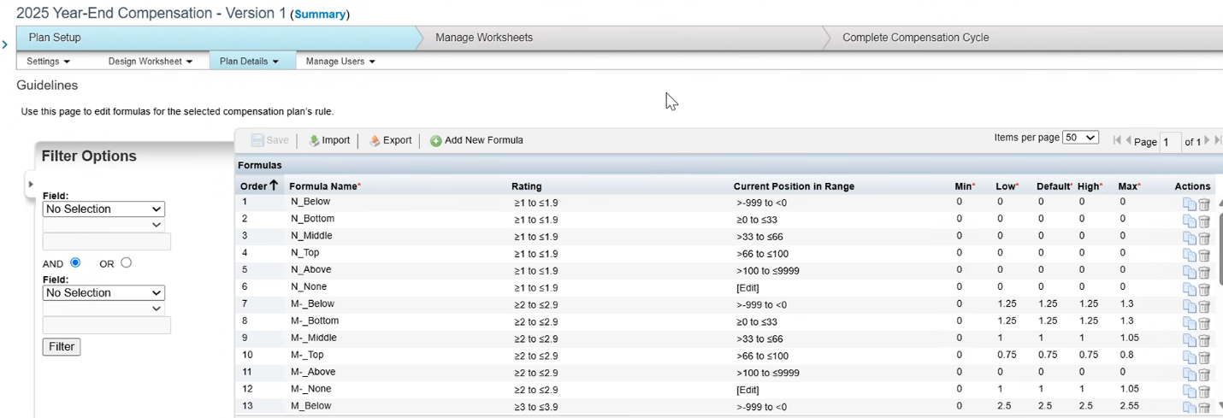

Current Position range - Comp metric
Std calculation that we use across the board. This is noth
TM salary - their range

Range Maximum & Range Mimimum- depends on your job level and the country

